Install nginx and run nginx on port number 81

Yum install nginx –y

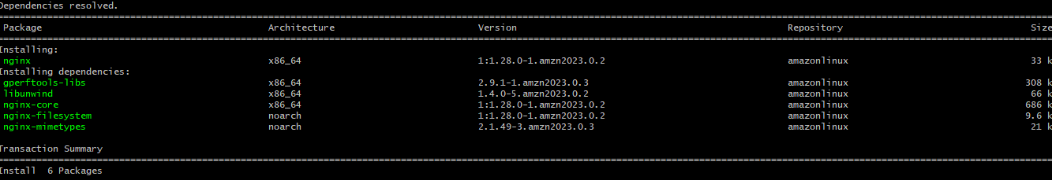

Open the find /etc/nginx/nginx.conf



Change the port from 80 to 81

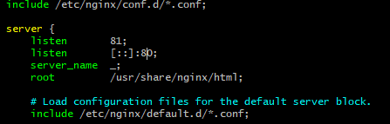



2. Deploy a sample index.html file on nginx.

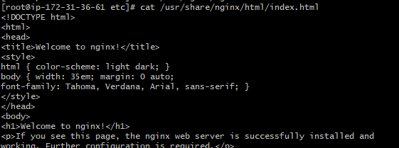

Vi index.html-welcome to techie horizon jyothi

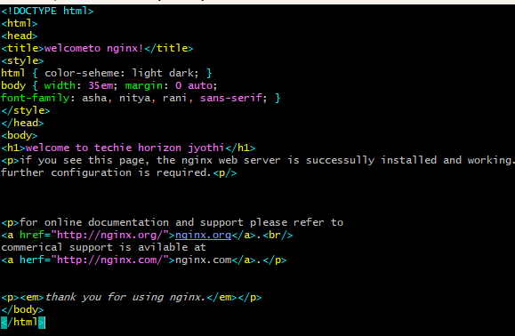

And check in browser the test page is update or not with port number 81



1. Install apache and run apache on port number 82.

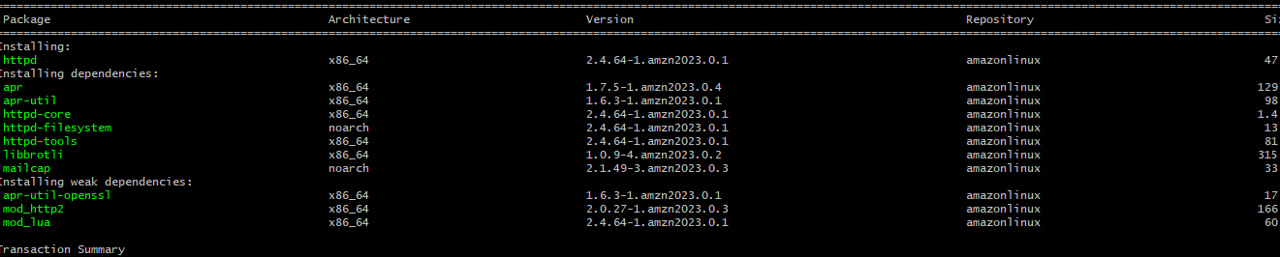

Start the httpd by using systemctl start httpd.

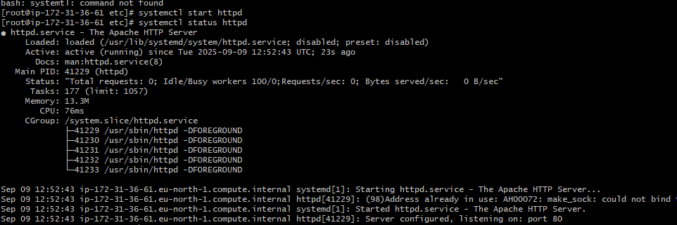

Netstat -na | grep 80: see the port number is running or not

Lsof -I tcp:80: it shows httpd is running

Ps -ef | grep httpd: here we can see the services related to httpd

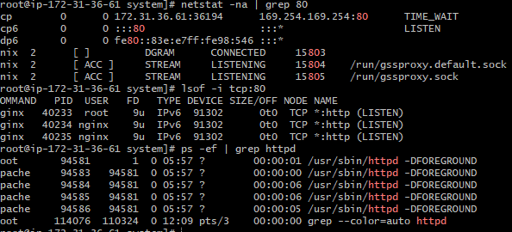

Change the conf file 80 to 82.



Paste the content and make port number 80 to 82

Listen 82

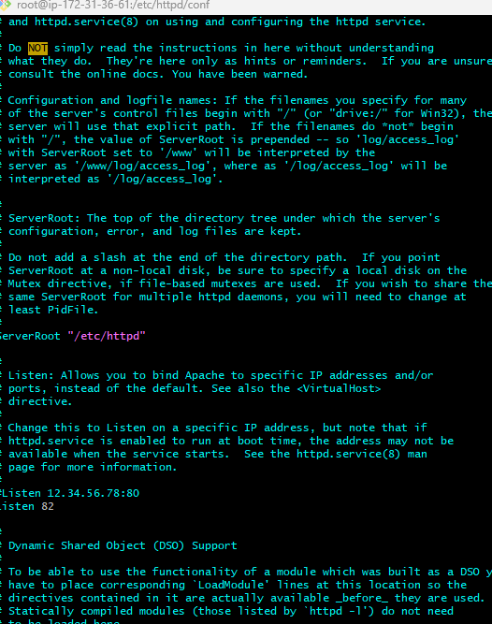

And you cross check in browser with port number 82



4.Deploy a sample index.html file on apache.

Default location cd /var/www/html

Ll – long list

Create a file index.html

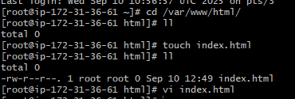

Vi index.html

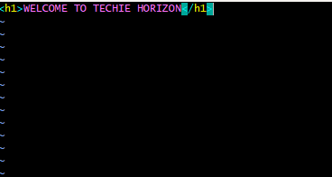

And go to browser and refresh, it shows



5.install apache tomcat on port number 8082

c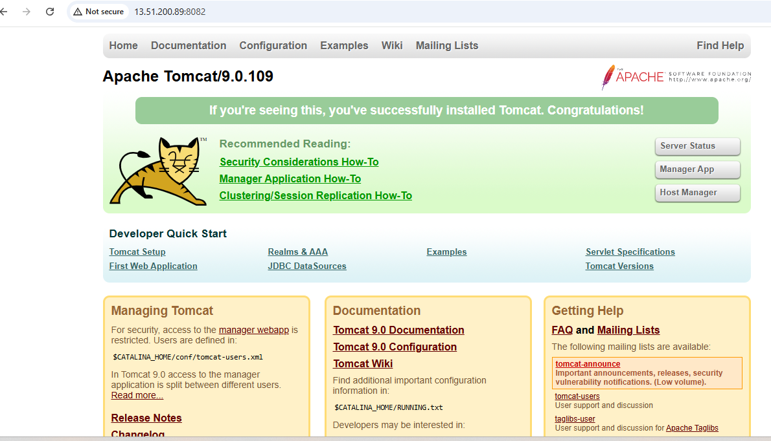

cd.. –one step back

cd conf -change directory to conf

ls -list of files

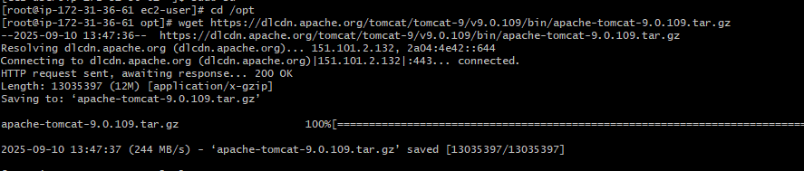

Ls -it shows the list of files



tar xvf apache-tomcat-9.0.109.tar.gz

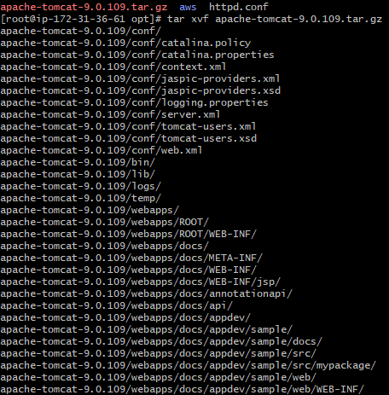

Ls -it gives list



ls -it will shows all configurations and files related to your tomcat



Cd bin/ -change directory to bin

ls – it shows the list of files



Yum install java -installed java

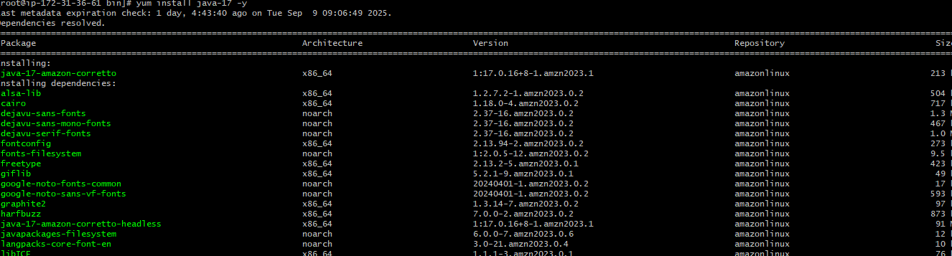

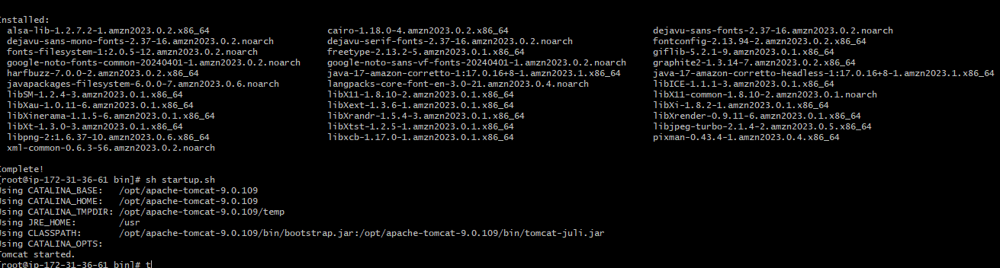

Ps - ef | grep tomcat –to check the running process of tomcat

Netstat –na | grep 8080 –check the port is running



bash startup.sh –tomcat started

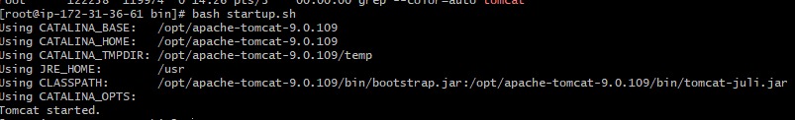

bash ./startup.sh – start the tomcat and give port number 8082

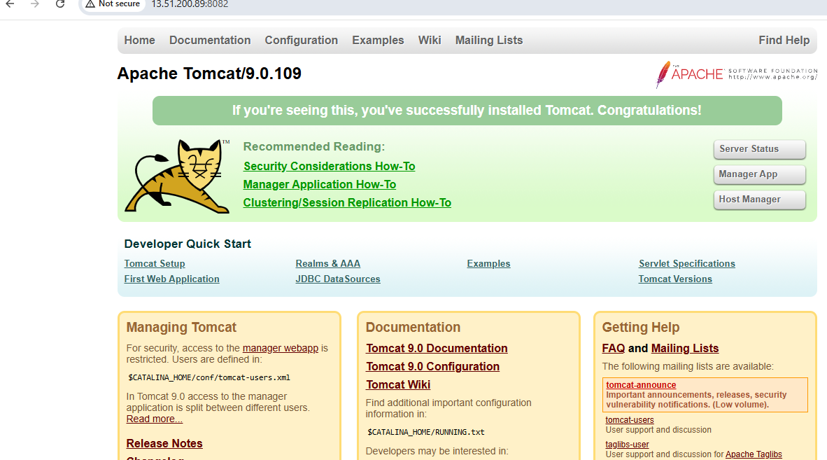

6.Deploy a sample app on webapps number 8082.

Cd .. –one step back

ls – list of files



Cd webapps –change the directory to webapps



Go to google and search sample.war



And here give right click and copy the link and paste it in gitbash

Wget link –to download the sample war

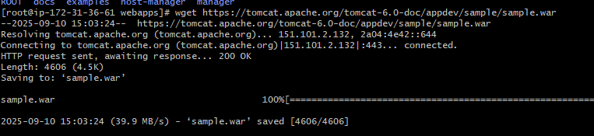

ll - it gives long list

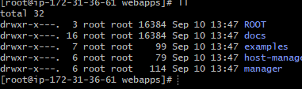

Go to google and check the public ip with port number 8082

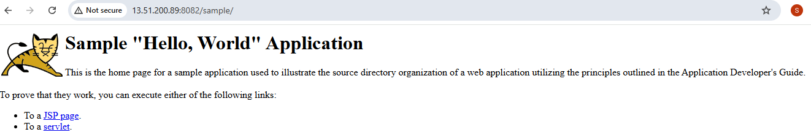

1. Create a tomcat.service file for tomcat.

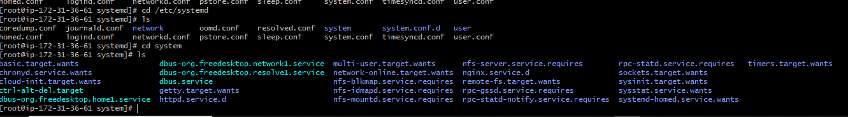

Go to default location of that is system

Add tomcat.service file : vi tomcat.service

Add configuration:

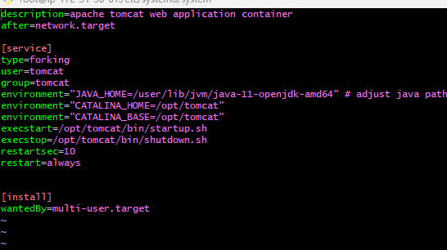

1. Configure HA proxy server.

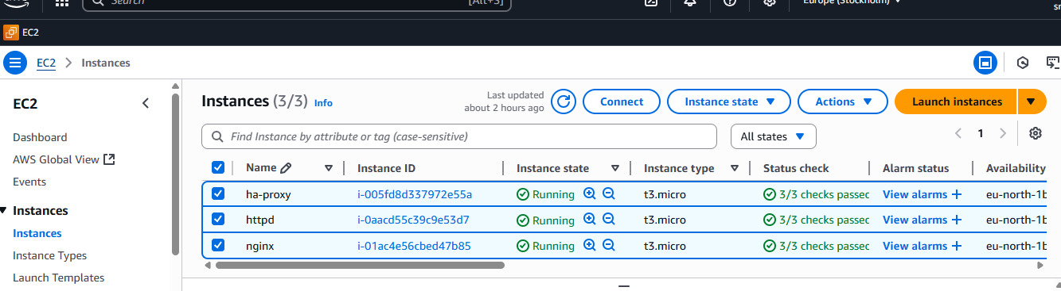

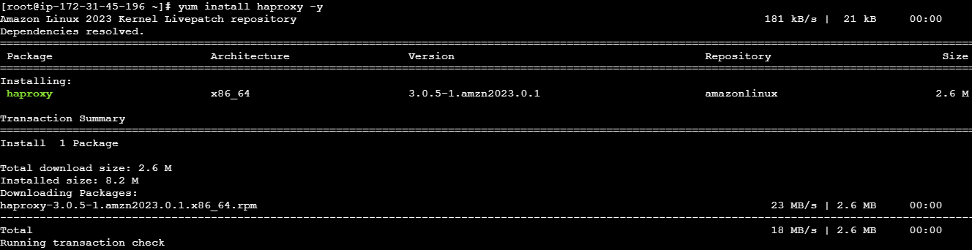

Systemctl start haproxy

Systemctl status haproxy

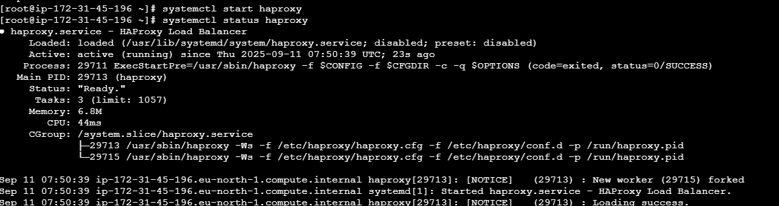

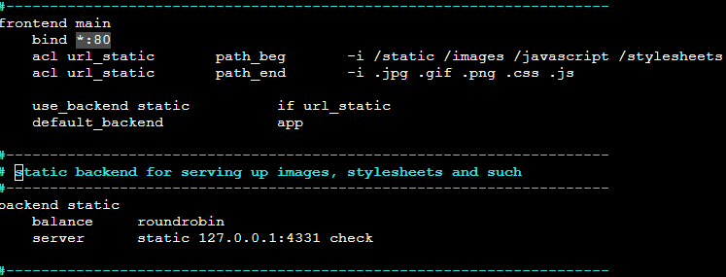







Steps:

Deploy a httpd server

Deploy a nginx server

Install a haproxy server

Yum install haproxy

Systemctl enable haproxy

Cat /etc/hosts(edit file and paste public ip of two servers with name httpdserver1:public ip nginxserver:public ip)

:wq!

vi /etc/haproxy/haproxy.cfg(paste public ip with port 80 extension of two servers also change listen port to 80 also change bind port to 80)

Bind:80

Server apps5 nginxpublicip:port check

Server apps6 httpdpublicip:port check

Systemctl restart haproxy

Systemctl status haproxy

Go to nginx server

vi /etc/hosts(paste publicip with name)

Go to httpd server

vi /etc/hosts(paste publicip with name)